Light Infantry Company

of the

7th Virginia Regiment

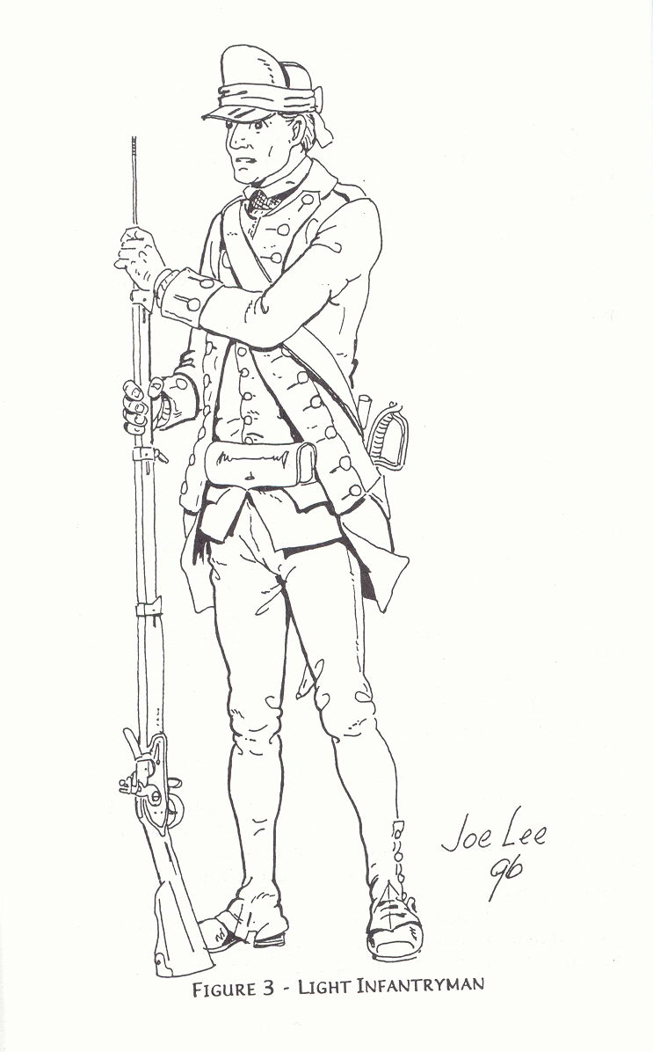

Image from “A Sketch of the Virginia Soldier in the Revolution”; Andrew Gallup; Heritage Books, Inc, 1999

Handbook

Light Infantry handbook

# Origins of the Light Infantry

References to light infantry are found as early as 1775 when the Virginia Convention specified that two of the eight companies making up the 1st and 2nd Virginia regiments were to comprise “expert rifle-men to be employed as light infantry.” In December 1775 Virginia raised six more regiments, increasing the companies of each to ten, three of which were “….rifle-men to act as light infantry.”[1]1

General Washington used riflemen as scouts and pickets throughout 1776, but never formally organized them into a light infantry unit. It wasn’t until 1777 that he put the light infantry on a more stable footing. In June 1777 he gave Colonel Daniel Morgan command of a newly formed rifle corps comprised of picked marksmen. They served as light infantry, providing much needed reconnaissance. They also engaged in a number of skirmishes throughout the summer.[2]2

When Morgan’s Rifle Corps was sent north to join General Gates at Saratoga, Washington raised a new corps of light infantry. Each brigade supplied one hundred men and the necessary officers, and the whole corps was commanded by General William Maxwell.[3]3 Unlike Morgan’s corps, this one had both rifles and muskets in it. Maxwell’s light infantry performed valuable service at the battles of Cooches Bridge and Brandywine, fighting well in advance of the main army as skirmishers.

By November, Maxwell’s corps was disbanded and the men returned to their original regiments. Morgan’s Rifle Corps, returned to Washington’s army in November and resumed its role as light infantry but it was reduced by illness and loss to only 170 men.[4]4 Other small units of, “picked men, fit for annoying the enemy in light parties”, were temporarily formed and then disbanded throughout the winter.[5]5

In May 1778 Congress formally incorporated companies of light infantry – one from each regiment – into the organization of the army. These companies were to be, “organized during the campaign into corps of light infantry.”[6]6 However, during the first half of 1778, it was Morgan’s rifle corps, bolstered by 25 of the best marksmen from each brigade, who was once again tapped to perform light infantry duties. These “borrowed” marksmen were to rejoin their regiments as soon as the enemy, who was then preparing to evacuate Philadelphia, passed through New Jersey.[7]7 Following the battle of Monmouth, these “borrowed marksmen”, along with most of the remaining riflemen in the rifle corps, were ordered to return to their original regiments. Colonel Morgan himself left the rifle corps to resume command of his own regiment, the 11th Virginia. Two companies of riflemen, however, were kept in tact and sent to Albany to help counter the Indian threat in that state. Captain Gabriel Long and his rifle company from the 11th Virginia made up one of the two companies and the overall command of the detachment fell to Major Thomas Posey of the 7th Virginia.[8]8

A new “Corps of Light Infantry, composed of the best, most hardy Marksmen and commanded by good Partizan Officers draughted from the several Brigades and commanded by Brig. Gen. Scott,” was raised in August 1778.[9]9 This corps operated as light infantry for the remainder of 1778, disbanding to rejoin their original regiments sometime in December.

In May 1779 regiments were once again ordered to form a light infantry company from among their ranks. On June 12, 1779 the 7th Virginia ( formerly the 11th ) was ordered, “to form one battalion with the 8th Virginia and furnish one company of Light Infantry.”[10]10 General Washington reminded regimental officers to choose their men wisely as they would reflect on the honor of the whole regiment. Three days later, sixteen light infantry companies were organized into four battalions, one of which was commanded by Major Thomas Posey of the 7th Virginia. The entire light infantry corps was placed under the command of General Anthony Wayne.

Wayne’s light infantry performed admirably at Stony Point in July 1779 and continued its service until the end of the year. On December 8, 1779 all of the Virginia troops of the light corps were ordered to Philadelphia to join the remainder of the Virginia line and march south.[11]11 The service of Virginia’s light infantry troops in Washington’s army was thus concluded.

Unfortunately, the capture of virtually the entire Virginia Line at Charleston, in May 1780, meant that very few Virginia continentals were left to serve. Small groups of them, those who had somehow avoided or escaped capture, joined the Southern army under General Gates and later General Greene. And although their numbers were small, they were able to form companies and serve, some even as light infantry, alongside continental troops from Maryland and Delaware at such important battles as Camden, Cowpens, and Guilford Courthouse.

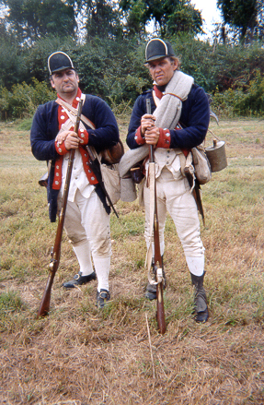

The light infantry of the southern army performed much like its counterparts had in the north, (ie. as advance parties, scouts, skirmishers, ect.) However, the troops in the south were not as well supplied, uniformed, or even organized. Light troops in Greene’s southern army distinguished themselves by their activities and tactics rather than their uniforms. Of course, those in the north had done similarly in the early years of the war. However, by 1781, the main army’s Light Infantry Corps, commanded by General LaFayette, was a distinctive and well polished corps. Lafayette himself provided red and black plumes for all the men and the officers received swords.

In the end, at Yorktown, it was the light troops under Lafayette who stormed redoubt 10, bringing the siege, and ultimately the war, to an end. These men, the special forces of their age, performed their task bravely, as light troops had throughout the war.

# Purpose of Light Infantry

Light infantry troops served a variety of functions in the continental army. They were usually positioned in the van and/or flanks of an advancing force. This reconnaissance and skirmish role meant that they were frequently first to engage the enemy.

However, light troops were rarely expected to engage the enemy in full-blown battles. Instead, they usually served as a blocking, delaying or probing force, occupying the enemy long enough for the main army to respond. If a battle became general in scope, the light infantry might form alongside the line troops in close order, or they might maneuver to harass the enemy’s flank.

When the main army was encamped, light infantry troops often served in small advance parties, performing scouting missions and serving as pickets. Such activities were often more demanding than the responsibilities of line troops, thus, light infantry troops were hand picked and often considered some of the best soldiers in the army .

# Tactics

As skirmishers, light infantry troops often fought differently than line troops. When they engaged the enemy, they often fought in open order and in pairs. Two men worked together, coordinating their shots to ensure that someone was always loaded.

Light troops were also expected to be very maneuverable. The standard deployment technique was to march in columns of two and deploy alongside the commanding officer, ( usually to his left ). Light troops fought in compact lines or in open or extended order. Open order involved extending the line so that gaps appeared between the files. These gaps could be small or large. The commanding officer determined the distance by announcing how many paces to extend. For instance, if the command was, “ Extend to the left five paces, the troops would come to trail arms, face left, and then quick march to the left, counting off five paces from the file behind them. If done correctly, the ranks should be extended left, from the officer, with five paces between each file. From there the troops could fight stationary, or advance / withdraw in a leapfrog fashion. If the battle became general, the light infantry would often reform and fight alongside the line troops of the main army.

# Organization

The light infantry corps was classified as a detached, or temporary unit. During the 1777 campaign season, brigades provided an allotment of picked men to serve in the light infantry. Starting in 1778 however, each regiment formed its own light infantry company, again made up of chosen men. These companies were then detached to the light infantry corps for the duration of the campaign season. It was expected that this corps be maintained at full strength throughout the campaign. When necessary, brigades were expected to provide replacements to bolster the light corps. At the end of the campaign season, the light corps was disbanded and the men returned to their original units.

# Light Infantry Impression

The 7th Virginia’s Light Infantry Company re-creates the 1777-1781 period, with an emphasis on June 1779. For most of the war the light infantry was clothed largely as the line troops. In fact, soldiers drew their clothing allotments from the same clothiers that supplied their individual regiments. This meant that while light troops from the same regiment probably wore similar attire, the light corps itself was anything but uniform.

However, since light infantry troops served on detached duty, ( meaning they would rejoin their original regiments at the end of the campaign season ) it was deemed imprudent to supply them with a special light infantry uniform. General Wayne apparently desired such a uniform but General Washington disagreed, telling Wayne in a September 14, 1779 letter that, “*The Light Infantry being only considered as detachments from the line ought to bear the uniform of the Regiments from which they are taken. Though this from the diversity of our uniforms, will not be so favourable to their appearance as might be wished, the contrary would be a deviation from common practice and would not fail to create uneasiness. Besides, whenever it should be found expedient to return them to their Regiments it would then produce a more disagreeable diversity in the Regiments to which they belong. So soon as the Cloathing for the Army can be brought on to camp a general distribution of uniforms will take place; to furnish a part sooner would excite jealousy and discontent*.”[12]12

In an even earlier letter to General Wayne, Washington wrote,

“ *I agree perfectly with you as to the importance of dress and it is my intention that the Infantry shall have a pretty full supply. But after all our circumstances must govern and it might have an ill effect to make too great a difference between the infantry and the troops of the line at large*.”[13]13

Clearly General Washington was concerned with the effect on the line troops that distinct light infantry uniforms might have. In that same letter to General Wayne, he did, “direct the Clothier to endeavour to complete you to a hat or cap, one Blanket, two shirts, one pr of overalls and one pr of Shoes pr man and a small quantity of thread and needles.” Aside from the cap, such items were nothing out of the ordinary from the line troops.

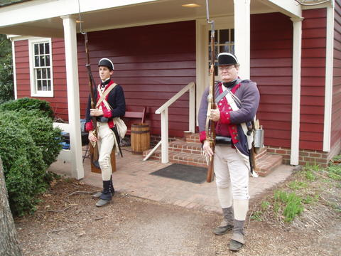

Apparently members of the 7th Virginia’s light company – detached to Wayne’s Corps—received caps rather than hats. Captain Robert Gamble, commanding the combined 7th and 8th Virginia’s light infantry company, noted in his October orderly book that, “General Wayne is unhappy because the Virginia light troops are the only ones without fur or hair on their caps.”[14]14

Aside from the obvious difference in tactics, the use of caps among light infantry troops may have been the one distinguishing difference between light and line troops. Such light infantry caps are noted as early as 1777 and were usually described as made of leather. However, in August and October 1780, General Wayne issued orders to his Pennsylvania troops to transform their old flop and cocked hats into infantry caps.

Thus, it is possible that the caps that General Wayne observed the Virginia light troops wearing in late 1779 were also made of felt rather than leather. Then again, it is quite possible that a good number of the Virginia light troops, especially early in the war, wore hats instead of caps.

As a result, members of the recreated 7th Virginia regiment’s light infantry company should outfit themselves like their line counterparts, primarily because **members of the light company are expected to be prepared to “fall in” with the line company at events that do not require a light infantry impression. This generally is the case at most events the 7th Virginia is involved in**. However, when appropriate for light infantry company members to appear as such at an event, they have a choice of using either a belly box or the shoulder carried cartridge box, and of adopting a felt or leather light infantry cap (see Figure 1). They should also remember that it’s the tactics and activities that essentially distinguish the light infantry, not the uniform. See appendix (A) of this handbook for instructions on constructing your light infantry cap.

## Figure 1: Light Infantry Soldier

(Image from “A Sketch of the Virginia Soldier in the Revolution”; Andrew Gallup; Heritage Books, Inc, 1999)



THE DRILL OF THE LIGHT INFANTRY COMPANY

# The Basics

All members of the Light Infantry Company must be able to demonstrate proficiency in linear tactics. It must be remembered that the light infantry perform as an additional duty, not an exclusive duty. The Light Infantry will be able to fall into the line and perform its duties without any visible difference.

# The Commands

For the light infantry to perform its duties efficiently (skirmishing, patrolling, moving through close terrain, etc.), an additional drill must be learned. The following list of commands, while not all inclusive, must be considered as a minimum standard of achievement.

1. Extend Left (or Right),
2. Extend from the Center,
3. Rear rank – offset,
4. Close Right (or Left),
5. Close to the Center,
6. Fire on the spot,
7. Advance while firing,
8. Retreat while firing
9. Advance by File(s),
10. Retreat by File(s),
11. Form on the Officer.

It should also be understood that, in most cases, when an order is given that requires the soldier to immediately face right (or left) and change position, the soldier will IMMEDIATELY, without additional orders, move his firelock to the "trail" position. Once the soldier has reached the desired location, he is to immediately face front and shoulder his firelock, and await additional commands.

# The Drill

1. In order to open up the platoon files, the platoon can be extended from the Right, Left, or Center. The officer will choose the manner that is best suited for the terrain and tactical situation. More often than not, the platoon will be extended to the Left (from the officer). The officer will give the command,

**“Platoon, Extend Left 2 Paces (or 3, 4, 5, 6, etc.), March.”**

Upon this command, everyone except the far right file will face left, drop their arms to the trail, and march to place 2 paces between them. They will space themselves in the following manner: The right front rank man stays in place facing the front, the man to his left marches 2 paces to the left and stops. When he stops, he shouts “Halt!” and faces to the front, bringing his arms to the shoulder. When the man marching in front of him hears “Halt!”, he immediately starts counting his own 2 paces. At his second pace he stops and shouts “Halt!”, faces to the front and shoulders his arms, and so on until the line is extended. If there is a second rank, they would move with their file partner and maintain proper cover on them. Upon the line being extended, the officer gives the command,

**“Rear Rank – Offset.”**

Upon this command, the rear rank takes one step to the right. The platoon is now properly extended and ready to maneuver and/or fire.

If the platoon is to **Extend Right**, the same actions would be performed except in the reverse direction. The rear rank would still step to the right when commanded to **Offset.**

1. In order to **Extend from the Center,** the center file (as designated by the officer) would stand fast, while files to the right would **Extend Right** and files on the left would **Extend Left.** The commands would be as follows:

**“Extend from the Center 2 Paces (or 3, 4, 5, 6, etc.), March. Rear Rank – Offset.”**

1. In order to reform the platoon at close order when extended to the left (or right) the command would be as follows:

**“Close Right (or Left), March.”**

Upon this command, the far right front rank man would stand fast. All other front rank men would face right, drop their arms to the trail, and march back to the far right man, halt, face to the front, and shoulder their arms. The second rank man would move with their file partner and stay covered on him.

The opposite would hold true when closing to the left.

1. In order to reform the platoon at close order when extended from the center, the command would be as follows:

**“Close to the Center, March.”**

Upon this command, the files that had previously opened to the right would face to the left, drop their arms to the trail, and march back to the center file. The files that had extended to the left would face right, drop their arms to the trail, and march back to the center file. When the files had closed on the center, they will face to the front, and shoulder their arms.

1. When the platoon is extended, it may receive the command to

**“Fire on the Spot”**

Upon receiving this command the front file partner will make ready, present, and fire his firelock. The rear file partner will stay at the shoulder. When the front file partner starts to “charge his cartridge” down the muzzle of his barrel, he will shout **“Ready”**, complete his reloading, and come to the shoulder. The rear file partner, upon hearing the command, **“Ready”**, will make ready, present, and fire his firelock. He will immediately commence reloading his firelock, and upon “charging his cartridge”, shall announce that he is **“Ready”.** The front file partner will commence the firing of his firelock, again. This command enables the platoon to provide a scattered and continual fire, while still ensuring that at least half of the platoon remains loaded at all times, and capable of engaging an immediate threat.

While **“Firing on the Spot”,** it is necessary to remain conscious of all safety concerns. The rear file partner must stay offset to the right of his front file partner, and when the rear file partner **“Presents”** his firelock, he should lean forward, in order to ensure the muzzle of his firelock stays well in front of the front rank.

When the order is given to **“Cease Fire”**, all platoon members will instantly come to the shoulder, and put the frizzen stall on the hammer of their firelock. If the officer requires the platoon to complete the loading of its firelocks, he will so order it.

1. At times it may be necessary for the platoon to advance upon the enemy while engaging them with fire (specifically, while skirmishing). This can be accomplished with the command,

**“Advance while Firing, 6 Paces (example), March.”**

The front rank stands fast while the rear rank marches six paces ahead of the front rank, passing on the right. Upon the rear rank halting, the officer will order them to make ready, present, and fire. They then load and come to the shoulder. While they are loading, the front rank passes to the left of the rear rank, and marches six paces ahead of the rear rank. The front rank halts and awaits the officer's command to fire. When the officer observes the rear rank “charging cartridge”, he will give the command, “to make ready, present, and fire” to the front rank. The front rank will commence reloading, and the rear rank will advance six paces past the front rank. In this manner each rank will continue to advance and fire alternately.

The officer, and/or his designee, will continue to give the commands to fire, so as to ensure that each rank stays in line and that it is safe to fire. At no time should any file partner advance ahead of their rank. The advance is to stay on line.

1. At some point it will become necessary for the light infantry to break off its engagement with the enemy. When this occurs the command will be the following:

**“Retreat while Firing, 6 Paces (example), March.”**

Whichever rank is ahead will make ready, present, and fire. They will then right about, come to the trail, march six paces to the rear of the other rank, front, and begin reloading. When they have “charged cartridge” the officer will order the second rank to “make ready, present, fire”. They then right about, come to the trail, march six paces to the rear of the other rank, front, and begin reloading. In this manner, both ranks retire, supporting each other.

1. There will be times when it will be necessary to move the platoon to the front in either single or double files. When this situation arises, the command will be as follows:

**“Platoon! From the Right! Advance by File(s)! March!”**

At the command, **“From the Right!”** everyone except the man at the right end of the line turns to the right and comes to the trail. At the command **“March!”** the man at the far right end of the line marches forward and every other man marches to the spot where the right hand man stood and wheels to the left to follow the man in front of them. When two ranks are involved, all of the platoon faces right, upon the command **“March!”** the first file executes a left wheel, and march forward, followed by the others behind them.

Once the "Platoon" has reached its desired position, the men will immediately reform to the front in their original position in line.

1. There may be a need to quickly move the platoon to the rear in either single or double files. This movement is accomplished with the following command:

**“Platoon! From the Right! Retreat by File(s)! March!”**

This movement is accomplished exactly as advancing by file, except that the far right man (or file) will wheel to the right, instead of the left.

Once the "Platoon" has reached its desired position, the men will immediately reform to the front in their original position in line.

1. At times it may become necessary to quickly deploy the platoon on a new front (in order to counter a flanking maneuver, etc.). The officer giving the command will accomplish this movement as follows:

**“Form on me!”**

The officer would step off towards the new position he wants the platoon to form on. The rest of the platoon would right face, come to the trail, and “snake” after the officer, keeping to the single or double file formation they were originally in. When the officer arrives upon the “new ground”, he would halt and face the new front. The platoon will form to the left of the officer at close order, face the new front, and come to the shoulder.

Historically, all light infantry drill was executed at the “quick time”. All of these drills have been shown executed at the “ordinary time”. If the drill is to be performed at the “quick time”, the command **“March, March!”** will be used. It is the duty of the officer to be conscious of the conditions of the ground, the physical condition of his men, and the safety hazards which should be considered when deciding to march at the “ordinary" or "quick time”. It should be remembered that the “quick time” is defined as a slight jog. The light infantry is never to move at a run, or in such a manner that good order cannot be maintained. The light infantry is not to move at the run for two reasons:

1. Running troops are unsure of their footing, which multiplies the chance of an injury occurring.
2. If infantry are observed running, especially the light infantry, it may appear to signal a general rout to the rest of the Line.

It is more important to sacrifice speed, in order to maintain unit cohesion.

# Conclusion

This Light Infantry drill may seem confusing at first. However with practice, proficiency is easily attained.

**Safety rules specific to Rifles (may also apply to Light infantry)**

The following are a set of safety rules unique to riflemen during engagements at reenactments, as the rifles are obviously different from the musket it various ways. As riflemen are often used as skirmishers in conjunction with the Light Infantry, it is beneficial for the light infantry to also be familiar with these safety rules as they may apply to this impression.

**SAFETY GUIDELINES FOR RIFLEMEN**

**OF THE CONTINENTAL LINE**

Rifles are distinctly different weapons than muskets, and safety guidelines for rifles must therefore be somewhat different from musket guidelines to be truly effective.

1. Due to the inherently different loading procedures of rifles event organizers and army commanders should expect rifle companies to be deployed only in open skirmish formation. Rifles should not be expected to fire volleys in a closed, shoulder to shoulder formation as line troops.

2. The use of flash guards on rifles is encouraged. Any rifleman without a flash guard on his firearm, should be placed to the extreme end of his lock side of the formation. All riflemen not having a flash guard must have a safe distance between each man to insure that no one gets hit with a flash. A rifleman without a flash guard must inform those around him of this situation before firing.

3. A frizzen stall should be attached firmly to the rifle by a leather thong to serve as a safety device between shots and when on the move with a loaded firearm. This frizzen stall should be made of thick leather and fit snugly upon the frizzen of the rifle.

4. Under no circumstances should the ramrod of the rifle be removed from the thimbles and placed down the barrel of the rifle while on the field. Safety inspections are the only exception.

5. The overall condition of a rifle is paramount to safety. The firearm must have a good lock to barrel fit, the flint must be held firmly in the jaws of the lock. All screws and pins must be present on the weapon and fit snugly in place. The inside of the barrel and the touch hole area should be rust free. The stock should be free of any cracks.

6. When using paper cartridge for the loading of a rifle, the cartridges must be pre-rolled off site. These cartridges should be rolled on a former of the proper caliber and have no metal closures such as staples. Cartridges should contain approximately 1.5 grains of  FFFg powder per caliber but should not exceed 80 grains per the Table of Maximum Loads in the Continental Line's **Guidelines To Safety and Black Powder Standards**.

7. If loading from a powder horn and measure, the powder horn must be a quality horn having a snug fitting plug on the small end of the horn. The horn should be free of any cracks. The plug should be attached to the horn strap to prevent its’ loss. The larger butt end of the horn must also have a tight fitting plug.

8. Under no circumstances should powder be poured from the horn directly into the muzzle of the weapon. The powder charge must first be poured into a safe measure before it is poured down the barrel of the rifle. Powder measures should be of the correct size load for the caliber of the weapon.

9. A rifleman must always be vigilant in replacing the horn plug after pouring powder into the powder measure.

10. The act of priming should only be done with a small separate powder horn of the same quality as the charging horn. This is to be done only after the rifle is loaded with the main powder charge by means of the measure.

11. The rifle pouch should be of a solid construction. For safety it should be sewn tightly together, not laced. This will help prevent sparks from getting inside to any paper cartridges being carried in the pouch. The flap of the pouch should be wide enough and long enough to cover the actual pouch opening properly. The flap should naturally fall shut and should never be left open during loading and firing. The strap should be of sound construction to prevent loss.

12. If cartridges are carried in the rifle pouch, a cartridge block must be used to carry them upright and to separate them one from the other.

13. All edged weapons carried by riflemen must be properly sheathed. Belt knives and axes must have a snug fitting sheath having a proper closure to insure the cutting edge cannot be exposed. It is suggested that these items be attached in some way to the belt to prevent their loss in the field.

14. Personnel safety is also a concern. A full canteen of water should be carried regardless of the weather conditions. Proper fitting foot wear is important as well. All clothing and kit should fit comfortably and not be restrictive of movement and breathing.

15. It is the personal responsibility of each participant to act as a safety officer for those around us. Each of us should watch out for any safety problem that may occur.

16. All riflemen should know the basic drill and marching maneuvers. The need for men to maintain a certain amount of “Quiet in the Ranks” is necessary to insure safety on and off the field.

17. While carrying powder in the horn or cartridge, smoking is prohibited.

18. Equipment, particularly powder horns, bags and weapons must be inspected prior to any firing demonstrations to be sure that all items meet these Safety Guidelines and that no one will reasonably be considered a safety hazard to another person. While it is not the intention to prevent anyone who is qualified from participating, any item that does not meet these Guidelines must not be used in firing demonstrations.

19. During firing demonstrations there should be no firing while someone within close proximity is loading. This is perhaps the single most common source of gun powder accidents. Firing a black powder weapon creates the greatest source of sparks, and loading a weapon creates the greatest exposure of gun powder. These two activities must not occur in the same spot at the same time.

## Endnotes

1. 1 William Hening, The Statutes at Large Being a Collection of All the Laws of Virginia from the First Session of the Legislature, Vol. 9, ( 1821 ) 18 and 76
2. 2 George Washington to Daniel Morgan, 13 June 1777 and General Washington to the Continental Congress, 22 and 28 June 1777 ( The George Washington Papers at the Library of Congress : Online )
3. 3 General Orders of the Continental Army, 28 and 30 August, 1777 ( The George Washington Papers at the Library of Congress : Online )
4. 4 George Washington to Nathaniel Greene, 22 November, 1777 ( The George Washington Papers at the Library of Congress : Online )
5. 5 General Orders of the Continental Army, 22 December, 1777 ( The George Washington Papers at the Library of Congress : Online )
6. 6 General Orders of the Continental Army, 7 June 1778, ( The George Washington Papers at the Library of Congress : Online )
7. 7 General Orders of the Continental Army, 22 June 1778, ( The George Washington Papers at the Library of Congress : Online )
8. 8 Richard B. LaCrosse, Revolutionary Rangers : Daniel Morgan’s Riflemen and Their Role on the Northern Frontier, ( Heritage Books, 2002 ), 19
9. 9 General Orders of the Continental Army, 8 August, 1778 ( The George Washington Papers at the Library of Congress : Online )
10. 10 General Orders of the Continental Army, 12 June 1779 ( The George Washington Papers at the Library of Congress : Online )
11. 11 George Washington to William Woodford, 8 December, 1770 ( The George Washington Papers at the Library of Congress : Online )
12. 12 George Washington to Anthony Wayne, 14 September 1779, ( The George Washington Papers at the Library of Congress : Online )
13. 13 George Washington to Anthony Wayne, 5 July, 1779 ( The George Washington Papers at the Library of Congress : Online )
14. 14 The Orderly Book of Captain Robert Gamble of the Second Virginia Regiment, Commanded by Colonel Christian Febiger, August 21 – November 16, 1779, R.O. Light Infantry, 22 October 1779 ( Online ) 20